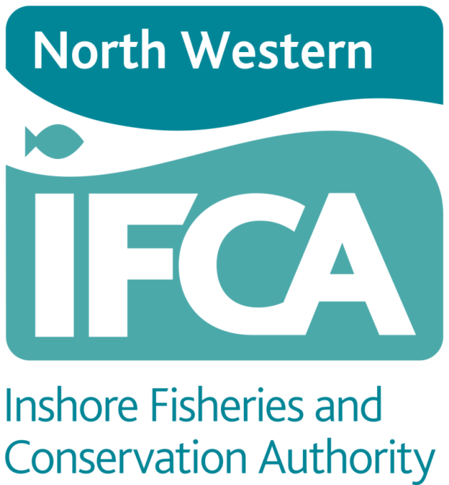

Marine Protected Areas

Fisheries Monitoring and Control Plan

Version 1.0

MK 18-10-17

NWIFCA M&C Plan Version Control

|  |  |  |
| --- | --- | --- |
| **History** | | |
| ***Date*** | ***Details of Revision*** | ***Contributors*** |
| 18/10/17 | Version (1) preliminary draft of Monitoring and Control Plan with tables to be further honed. | MK |
|  |  |  |
|  |  |  |

**NWIFCA MPA Fisheries Monitoring and Control Plan**

1. Introduction

**1.1 European Sites**

In 2012, the Department for Environment, Food and Rural Affairs (Defra) announced a revised approach to the management of commercial fisheries in European Marine Sites (EMS). The objective of this revised approach is to ensure that all existing and potential commercial fishing activities are managed in accordance with Article 6 of the Habitats Directive.

This approach has been implemented using an evidence based, risk-prioritised, and phased basis. Risk prioritisation was informed by using a matrix of the generic sensitivity of the sub-features of EMS to a suite of fishing activities as a decision making tool. These sub-feature-activity combinations were categorised according to specific definitions, as red, amber, green or blue. Activity/feature interactions identified within the matrix as red risk had the highest priority for implementation of management measures by the end of 2013 in order to avoid the deterioration of Annex I features in line with obligations under Article 6(2) of the Habitats Directive. Activity/feature interactions identified within the matrix as amber risk required a site-level assessment to determine whether management of an activity was required to conserve site features. Activity/feature interactions identified within the matrix as green also required a site level assessment if there are “in combination effects” with other plans or projects.

Some European Sites within the NWIFCA District consist of features that are not fully marine (eg. sand dunes) and therefore fall outwith of the EMS Review process. They were been included in the original risk matrix. Due to the nature of some of the fisheries in the NWIFCA District, particularly intertidal fisheries, the NWIFCA adopted the approach of carrying out full HRA on all the features (including non-marine) within European Sites to ensure that any potential risk from fishing activity was identified and assessed.

Site level assessments were carried out in a manner consistent with the provisions of Article 6(3) of the Habitats Directive, that is to determine that fishing activities are not having an adverse effect on the integrity of the site, to inform a judgement on whether or not appropriate steps are required to avoid the deterioration of natural habitats and the habitats of species as well as disturbances of the species for which the areas have been designated, in so far as such disturbance could be significant in relation to the objectives of this directive.

If measures were required, the revised approach required these to be implemented by the end of 2016.

**1.2 Marine Conservation Zones (MCZ)**

The UK government has designated four Marine Conservation Zones in the NWIFCA District under the Marine and Coastal Access Act 2009 (MACA 2009) since 2013. Individual MCZ site assessments will be carried out for fishing activity within these four designated MCZs, to document and determine whether management measures are required to further the conservation objectives of the Marine Conservation Zone (MCZ). The IFCA’s responsibilities in relation to management of MCZs fall within the 6nm area and are laid out in the MACA 2009. MMO is responsible for MCZ management beyond 6nm. In straddling sites the two regulators work together, with MMO taking the lead, and responsible for the assessments with IFCA activity data. Any change in activity levels will be reported to MMO

**2. Need for M&C Plan**

In order to have full confidence in the management of fishing activity within MPAs providing the optimum protection to features and sites, it is necessary to continuously monitor for accuracy of data and change. It is also a prerequisite to have a mechanism for control, including detection of breaches in management, enforcement, quick-response should change occur, review of existing measures and enhanced management if required.

Monitoring provides confidence in the following:

a) management measures are effective – includes EU, National and Regional legislation;

b) activity data at time of assessment was correct;

c) activity levels are not increasing or methods changing;

d) feature condition remains favourable;

e) risk to features remains low.

3. Our Approach – how we monitor and control

All details of individual fishing activity within a site, including full description of the site, its features and sensitivities, details of fishing activity, effort, seasonality, spatial extent, gear and potential risk, as well as existing management, are contained within the individual HRAs or MCZ assessments. These are published on the NWIFCA website - <http://www.nw-ifca.gov.uk/marine-protected-areas/hra/> and shared with other regulators and conservation bodies through the HUDDLE web portal ‘Management of Fisheries in Marine Protected Areas’ pages. Referring to these documents negates the need to repeat this information within the M&C Plan.

The NWIFCA M&C plan contains a suite of tables incorporating existing and on-going fishing activity within each MPA, a set of parameters which will be monitored with accompanying trigger levels. Most triggers are specific and measurable and set from expert knowledge and judgment. At any time if concerns are raised by Natural England over potential risk or change to a site’s Conservation Objectives (ES) or General Management Approach (MCZ), or to features’ vulnerability or sensitivity, a Review will be activated.

An Annual Review Date (ARD) is also built in to ensure any changes across all parameters are picked up. A detailed assessment of annual IFCO sightings data will be carried out. Should a trigger(s) be actioned between ARDs, the existing HRA / MCZ assessment will be reviewed with up to date data on fishing activity, evidence and research.

‘Illegal Activity’ and ‘New Fisheries’ will be assessed monthly to ensure implementation of appropriate management as soon as emerging threats have been detected.

Natural England will be asked to advise on any Review carried out, and the Review and its findings will be documented.

Monitoring of Activity and Effort is carried out using the following sources of data:

* IFCO Sightings – patrols both at sea, in ports and harbours, and shore based;
* through discussion at NWIFCA IFCO meetings;
* INTEL reports for illegal activity;
* MCSS data and MCSS MPA activity monitoring programme (requested report) from MMO;
* MMO landings data - a request for landings data will be submitted at the end of each calendar year.

Monitoring of Site and Feature condition is carried out using the following sources of data:

* **Annually** from season reports and communications with site managers & NGOs of features’ status;
* Natural England’s six yearly site condition monitoring - the most recent assessment will be used;
* any interim ‘risk’ reports from Natural England.

4. Management Options

In such case as a Review concludes that fishing activity could have an adverse effect on the designated feature of a protected site a suite of management options will be evaluated and recommendations for management consulted upon where appropriate.

Management Options (adapted from Northumberland IFCA Static Netting M&C Plan)

i. Voluntary Code of Conduct – unlikely to be used if risk is deemed high

ii. Byelaw – Prohibitive - permanent prohibitions on activity if evidence of risk shows high or unacceptable

iii. Byelaw – Permissive - Flexible Permitting – incorporating a range of conditions attached to the permit such as:

* temporal closures
* spatial closures – permanent and temporary
* effort limitation – restrict number of permits
* gear limitations
* TACs and quotas

iv. Emergency Byelaw – for unforeseen risks

**5. Cockle and Mussel Fisheries**

The NWIFCA District has a total of six ES in which cockle and mussel fisheries could occur, totalling 36 beds. Due to the high natural variation of cockle and mussel fisheries with the NWIFCA District that come and go, are unpredictable in extent and abundance, each fishery undergoes an individual HRA with in-built management and mitigation measures. These are the most closely managed fisheries in the District, in terms of regulation, assessment, multi-agency joint working and enforcement. As a result they each have individual parameters and triggers that cannot be defined in an overall plan such as this. They have subsequently not been included in this M&C Plan.

6. New Fisheries or Change in Regulation

IFCO Enforcement officers constantly monitor fishing activity, as well as gathering and sharing intelligence with other agencies. Should new fisheries develop within MPAs this will automatically trigger a new assessment which will be documented in the relevant site page(s) of the M&C Plan.

A change in regulation that reduces levels of control is unlikely. New regulation is generally brought in to tighten and strengthen existing controls. However it could necessitate the revocation of existing measures to avoid duplication. A check to ensure no gaps in management are created will be triggered for any Change in Regulation and documented in the relevant site page(s) of the M&C Plan.

7. Review of Monitoring and Control Plan

As the first iteration, this plan will be reviewed 12 months after its implementation to ensure it is fit for purpose, or earlier should concerns be highlighted. Version control is documented at the beginning of the document.

Once confidence has been established in its robustness, the NWIFCA M&C Plan will be reviewed on a five yearly basis.

