**1. Your Details**

|  |  |  |
| --- | --- | --- |
| **1a**. Full Name |  | **1b**. Date of Birth |
|  |  |  |
|  |  |  |
| **1c**. Address (including postcode) |  | **1d**. Telephone Number |
|  |  |  |
|  |  |
|  | **1e**. Mobile Number |
|  |  |
|  |  |  |
|  |  | **1f**. Email |
|  |  |  |

You **must** inform us if you change address during the period of permit.

**2. Vessel Details (if applicable)**

|  |  |  |
| --- | --- | --- |
| **2a**. Name of Vessel (if applicable) |  | **2b**. Port Letter and Number (PLN) (if applicable) |
|  |  |  |
| **2c.** Vessel Registration Number (if applicable) |  | **2d.** Defra Fishing Licence Type/No. (if applicable) |
|  |  |  |

**3. Fishing Area (see map on separate sheet) – you must tick at least one box**

|  |  |  |  |  |  |
| --- | --- | --- | --- | --- | --- |
| **3a. Byelaw 26 & 27 (fixed and mobile engines)** | |  | **3b. Byelaw 26 (Fixed Engines Only)** | | |
|  | Areas 8, 9, 10 and 11 |  |  | | Area 5 (Whitebait Nets Only ) |
|  |  |  |  | Areas 2 & 3 (Flue Nets Only) | |

**4. Net Details**

|  |  |  |
| --- | --- | --- |
| **4a**. Type and number of nets used |  | **4b**. ID Letters/Numbers |
|  |  |  |
|  |  |
|  |  |

**5. Declaration**

By signing, you declare that the information you have supplied on this form and supporting forms is correct.

|  |  |  |  |  |  |
| --- | --- | --- | --- | --- | --- |
| **5a.** Signature | |  | | **5b.** Date | |
|  | |  | |  | |
| **Office Use Only** | |  | | | | |
| **Date Application Rec’d:** | | **Date of Issue:** | | **Date Permit Posted:** | | **New Permit Number:** |
|  | |  | |  | |  |

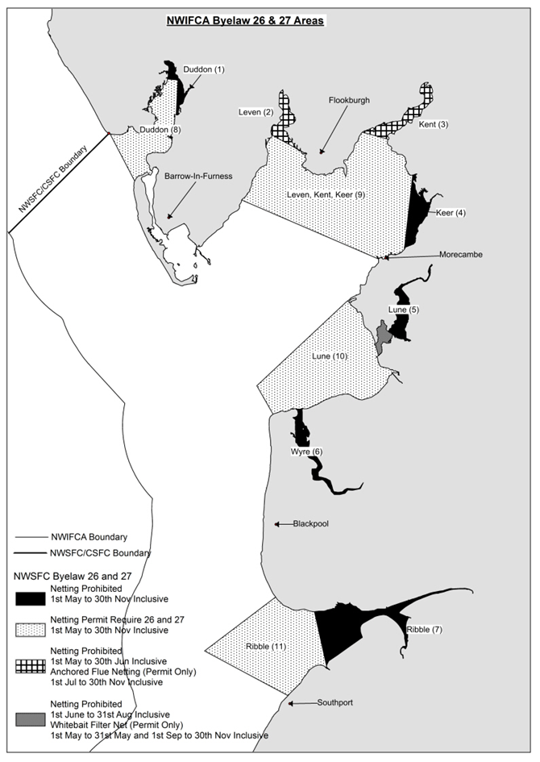

**GUIDANCE NOTES**: Please refer to these notes when completing **Form B2627**

**SECTION 1: YOUR DETAILS (to be completed by all applicants)**

**1a-c.** Supply the information requested on the form.

**1d-e**. Please provide at least one telephone contact number.

**1f.** Providing an email address is optional but it will allow us to contact you quicker regarding you permit application and with information directly related to your permit.

**SECTION 2: VESSEL DETAILS (only complete this section if you are fishing from a vessel)**

**2a.** If your boat has no name please write NO NAME in capital letters.

**2b-d.** Provide the details as applicable.

**SECTION 3: FISHING AREA**

Please refer to the map on the reverse of the application form and tick the appropriate boxes.

**3a.** A combined authorization will be issued for areas 8, 9, 10 and 11 under both Byelaw 26 and 27.

**3b.** Separate authorisations will be issued for flue netting in areas 2 & 3 and whitebait nets area 5**.** Please note the gear restrictions within Area 5 and Areas 2 & 3.

**SECTION 4: NET DETAILS**

**4a.** List the type and number of nets you will be using.

**4b.** Put the ID markings you will be putting on your nets. This allows us to identify who the net belongs to and to contact you regarding any issues. Any nets that are not marked will be seized.

**SECTION 5: Declaration**

**5a-b.** Please sign and date the form. Unsigned applications will not be processed.

If you have any questions regarding completing this form please contact us by e-mail at office@nw-ifca.gov.uk or by phone on 01524 727970 (option 2).

Mark Taylor

Chief Executive Officer

**Privacy Notice**

**Who are we?**

North Western Inshore Fisheries and Conservation Authority (North Western IFCA) was formed in 2011 to manage the sustainable exploitation of sea fisheries resources within the North Western IFCA district. The district spans from the Welsh Border in the Dee Estuary to the Scottish Border in the Solway Firth. The area covered includes coastal Council landward areas and sea areas up to 6 nautical miles off shore.

**What legal reason is my data processed for?**

We have a duty to manage the sustainable exploitation of inshore fisheries resources and to create and enforce byelaws under the Marine and Coastal Access Act 2009. In order to manage the systems established in Byelaw 3 we need to process your personal data.

**Will my information be shared with any third party?**

We only disclose the information provided in this application form to other statutory agencies or organisations for the prevention and detection of crime. The Authority uses third party providers for IT services and permit management. All providers of services to the Authority are subject to the same conditions when handling your information. Your information is not sold to any third parties or shared for marketing purposes.

**How is my information held?**

Your physical application form and supporting documents will be stored securely.

A digital copy may be retained and a digital record will be created of the information supplied as part of our permit record keeping.

**How long will my information be held for?**

Your application form will be destroyed within one month of the permit expiring.

Your supporting documents will be destroyed upon the approval of your permit. A record will be maintained that the documents have been witnessed.

The digital record will be retained for 7 years after your last permit expires. Following this a reduced record of name, permit, date of birth, town and postcode will be held on record.

If you submit an incomplete application the application form will remain on record for 7 years from the date of application or until you formally withdraw your application.

**Who do I contact about the information you hold?**

If you would like to access any of the information we hold about you or you have concerns regarding the way we have processed your information please contact:

By post: Mr Mark Taylor NWIFCA, 1 Preston Street, Carnforth, LA5 9BY

By email: office@nw-ifca.gov.uk

If you wish to raise a complaint, we would prefer any complaints to be made to us initially so that we have the opportunity to see if we can put things right.

If you are unhappy with the way we have processed your information or how we have responded to your request to exercise any of your rights in relation to your data, you can raise your concerns direct with the Information Commissioner’s Office.