# English Coastal Challenge Summit

**10 a.m. – 4 p.m., 24th April 2018**

**Europe House, Smith Square, London SW1P 3EU**

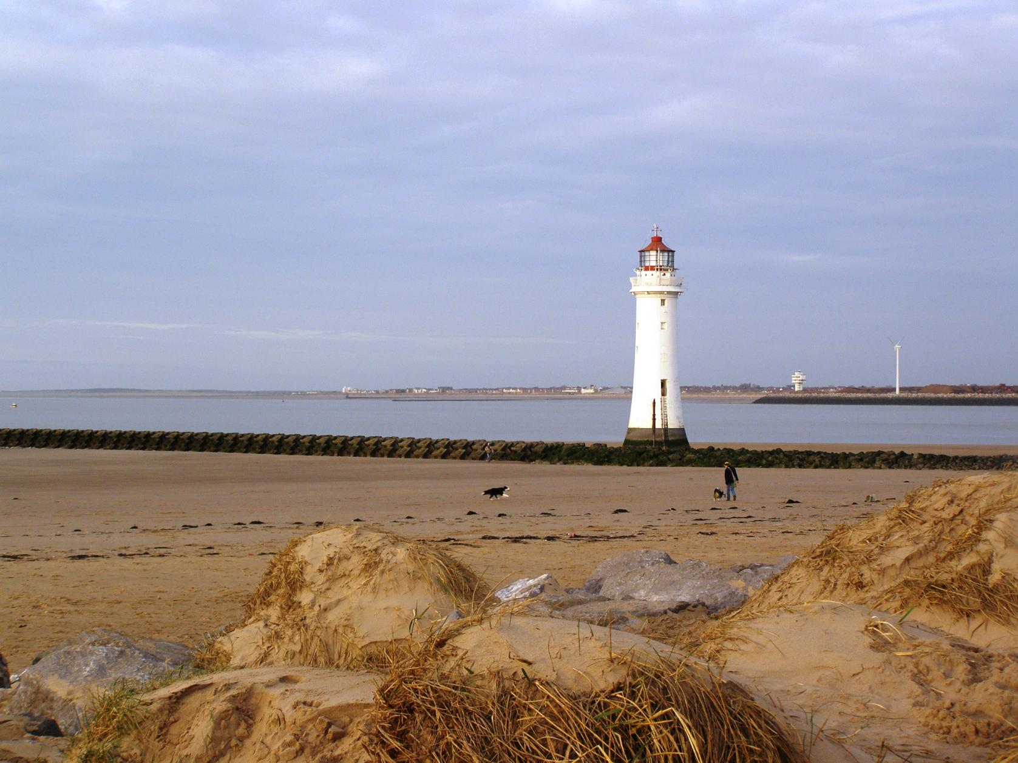

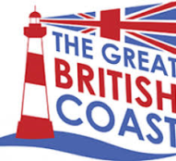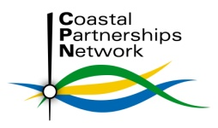

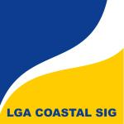

# Why now?

Our coast and its communities face a range of complex challenges and opportunities. At a national level the current sectoral approach to the management, regeneration and promotion of our coasts is acting as a brake on the potential of coastal communities to thrive. In response to this a variety of different groups and networks have formed, all with differences in focus but significant overlaps of interest.

England’s first Coastal Challenge Summit will bring together the experience, influence, enterprise and ambition of Coastal Partnerships, Coastal Community Teams, Local Enterprise Partnerships and other coastal stakeholders to network and innovate in a ‘Challenge’ style event.

# English Coastal Challenge Summit Aims

* **To explore and build opportunities for collaboration**
* **To address parallelism and duplication**
* **To start the process of developing 21st Century policies and actions for our coastal communities, industries and assets**

# Who should attend?

# This event is aimed primarily at participants actively involved in Coastal Partnerships, Coastal Community Teams and other coastal networks so those delegates will be given priority when booking.

# Cost

With generous sponsorship from the Local Government Association Coastal Special Interest Group and the Coastal Communities Alliance we can offer places at just **£20** each. There are a limited number of concessionary places available to those who may not have the budget.

# Organiser and Sponsors

The event is organised by the Coastal Partnerships Network**,** the national body for Coastal Partnerships, which seeks to develop national approaches to common issues and to promote better integration of management on the coast. It is sponsored by theLocal Government Association Coastal Special Interest Group and the Coastal Communities Alliance.

# CPN logo.JPG

# English Coastal Challenge Summit

24th April 2018, Europe House, Smith Square, London SW1P 3EU

# Registration Form

###### Please complete **1 form for each delegate** in block capitals and **return before 31st March** to:

Coastal Partnerships Network Secretary Lucy Taylor [TaylorL14@cardiff.ac.uk](mailto:TaylorL14@cardiff.ac.uk) 02920 874713

*Confirmation of your place and further details will be sent within a week of receiving your registration request*

**Delegate Name:**

**Job title:**

**Organisation:**

**Address:**

**Telephone:** **Email:**

**IMPORTANT: Are you involved in a Coastal Partnership, Coastal Community Team, Local Enterprise**

**Partnership, coastal local authority or another coastal group / forum? Yes / No**

**If yes which and where?**

**The cost to attend the English Coastal Challenge Summit is £20.**

*Billing will be via Eventbrite through a link sent to you when your registration is confirmed. Alternative invoicing and payment arrangements can be made if needed.*

**Please indicate here if you would like to be considered for one of the limited concessionary places**

*You will be contacted to discuss your request.*

**Please indicate any special dietary or other requirements in the space below:**

**Would you like us to hold your details on the Coastal Partnerships Network mailing list for CPN News**

**and other directly relevant communications? Yes / No**

*Details will never be shared with other organisations without first seeking your explicit consent.*

***Please note:***

* *It may be necessary for reasons beyond our control to change the venue, content, speakers or timing of the programme. Where this happens we will make every effort to let you know as soon as possible*
* *Except in the event of a major change to the content, location or timing we reserve the right to charge a cancellation fee of £20 for cancellations made less than 7 working days before the event (substitutes will be accepted)*