**1. Your Details**

**NWIFCA requires you to submit this application for track record together with your application for a Category One potting permit for whelks to ensure all documentation required to process these applications is provided**

To apply for a track record you must be the owner of the named relevant fishing vessel. Where joint ownership exists please provide details of the lead applicant and main point for correspondence as provided on your permit application form.

|  |  |  |
| --- | --- | --- |
| **1a**. First Name |  | **1b**. Last Name |
|  |  |  |
|  |  |  |
| **1c**. Address (including postcode) |  | **1d**. Telephone Number |
|  |  |  |
|  |  |
|  | **1e**. Mobile Number |
|  |  |
|  |  |  |
|  |  | **1f**. Email |
|  |  |  |

**2. Company Details**

If the vessel is owned by a company complete this section. If not, skip to Section 3.

|  |  |  |
| --- | --- | --- |
| **2a**. Name of Business | | |
|  | | |
|  |  |  |
| **2b**. Address of Business (including postcode) |  | **2c**. Business Telephone Number |
|  |  |  |
|  |  |
|  | **2d.** Business Email |
|  |  |
|  |  |
|  |  |
|  |  |

**3. Vessel Details**

|  |  |  |
| --- | --- | --- |
| **3a**. Name of Vessel |  | **3b**. Port Letter and Number (PLN) |
|  |  |  |
|  |  |  |
| **3c.** Vessel Registration Number |  | **3d.** Vessel Overall Length (metres) |
|  |  |  |
|  |  |  |
| **3e.** Vessel Registered Length (metres) |  | **3f.** Vessel Registered Gross Tonnage |
|  |  |  |
|  |  |  |

**4. Evidence to support your application for track record for a whelk potting permit**

**4a.** I am providing evidence of my track record of fishing for whelks for the period 2015 - 18 in:

(tick all that apply and refer to guidance note and map):

i. 0 – 6 nm in ICES rectangles 35E7, 36E6, 36E7, 37E7 and those parts of ICES

rectangles 35E6 and 37E6 that fall within the NWSFC District

ii. 6 -12 nm in ICES rectangle 37E6

iii. Areas in ICES rectangle 38E6 that lie outside of the CSFC District

**4b.** I am providing evidence of:

i. Sale notes / proof of payments for vessels under 10m OAL

ii. Positional data from vessel plotter or navigation aid

iii. Logbooks for vessels over 10m

iv. VMS tracks for vessels over 12m

**4c**. Minimum landings of 5 tonnes in the qualifying period

**5.** **Have you replaced your vessel since the track record period of 2015-18?**

**If the answer is no skip to section 6**

If so, please provide details here, including name and PLN of old vessel, name and PLN of new vessel, proof of ownership of new vessel, copies of bill of sale for sold vessel, receipt for purchase of replacement vessel, and any other documentation that shows evidence of your change of vessel.

|  |  |  |
| --- | --- | --- |
| **5a**. Name of Old Vessel |  | **5b**. Port Letter and Number (PLN) of Old Vessel |
|  |  |  |
|  |  |  |
| **5c**. Name of New Vessel |  | **5d**. Port Letter and Number (PLN) of New Vessel |
|  |  |  |

|  |
| --- |
| **5e**. Please list documentation provided |
|  |

**NB: A track record may be transferred from a donor vessel to a recipient vessel providing the ownership of the recipient vessel is the same as that of the donor vessel. Transfer of a track record removes all of the track record from the donor vessel.**

**6. Checklist**

Please check that you have enclosed with your application copies of the following documents:

|  |  |  |
| --- | --- | --- |
| **6a. All Applications** | |  |
|  | Copies of Sales notes or proof of payments for whelks |  | |
|  | Positional data from vessel plotter or navigation aid |  | |
|  | Copies of logbooks |  | |
|  | VMS tracks for vessels over 12m |  | |
|  | Details of old and replacement vessels (if applicable) |  | |
|  | Any other evidence. Please state additional evidence supplied: |  | |

**7. Your Signature**

By signing, you declare that the information you have supplied on this form is correct.

|  |  |  |
| --- | --- | --- |
| **7a.** Signature |  | **7b.** Date |
|  |  |  |

|  |  |  |  |
| --- | --- | --- | --- |
| **Office Use Only** | **Date of Receipt of Application** | **Date of Issue** | **Date of Issue of Whelk Permit** |
| **Track Record Application Number:** |  |  |  |

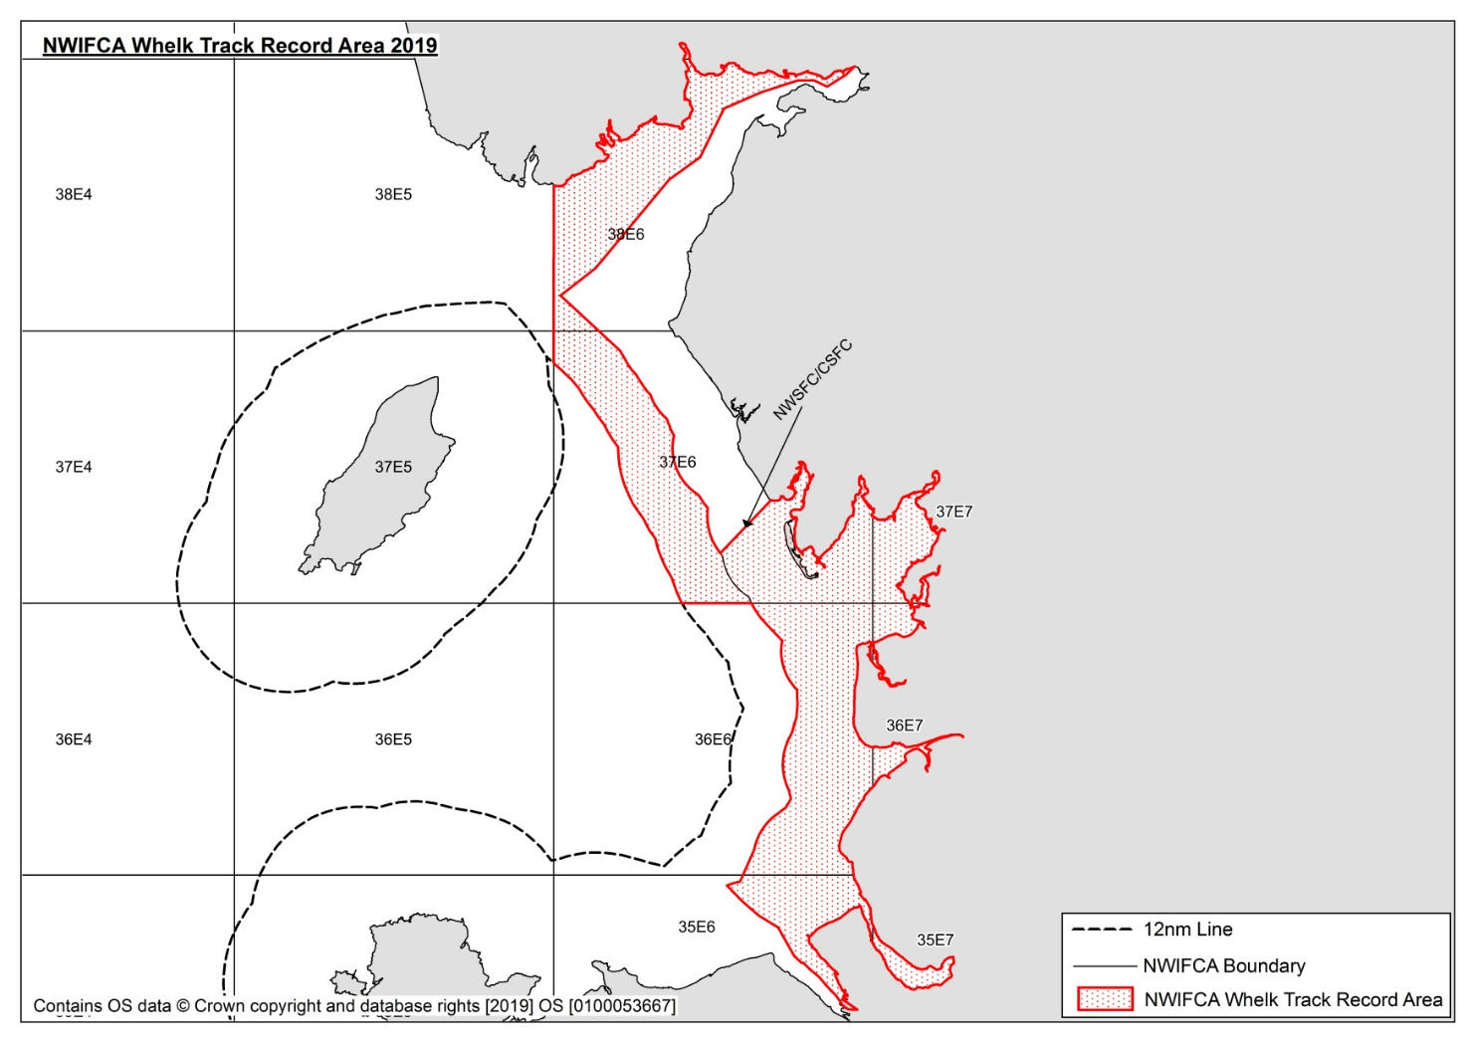

**GUIDANCE NOTES**: Please refer to these notes when completing **Form PTRW**

**SECTION 1: YOUR DETAILS**

**To be completed by the owner or the lead applicant in cases of shared ownership of the vessel.**

**1a-f.** Supply the requested details. For applications with shared ownership of the vessel provide the details of the lead applicant.

**SECTION 2: COMPANY DETAILS**

**To be completed if the vessel is owned by a company. If the vessel is NOT owned by a company skip to section 3**

**2a-d.** Supply the requested company details.

**SECTION 3: VESSEL DETAILS**

**To be completed by ALL APPLICANTS**

**3a-f.** Please provide the details of the vessel for which you are applying for track record.

**SECTION 4: EVIDENCE TO SUPPORT YOUR APPLICATION FOR TRACK RECORD FOR A WHELK POTTING PERMIT**

**To be completed by ALL APPLICANTS**

Supply as much evidence as defined as possible to support your application.

**4a. i - iii.** Tick the areas for which you are supplying evidence of whelk potting for the period 2015 - 18.

**4b. i - iv.** Tick all the types of evidence you are supplying with your application.

You are entitled to apply for your VMS data from the MMO. Please note MMO have 40 calendar days to respond to your request: <https://www.gov.uk/government/publications/vessel-monitoring-system-data-request>. If possible please provide the excel spreadsheet, as well as any screenshots in pdf format.

**4c.** Tick whether or not you are providing evidence of a minimum of 5 tonnes of whelk landings for the qualifying period.

**SECTION 5: HAVE YOU REPLACED YOUR VESSEL SINCE THE TRACK RECORD PERIOD OF 2015-18?**

Skip this section if you have not replaced your vessel.

**5a-d.** Provide the requested details

**5e.** List any additional information and additional documents included.

**SECTION 6: CHECKLIST**

**6a.** Check over your supporting documents to ensure they are all present. If you are providing additional documents that are not listed please tick the ‘any other evidence’ box and list the documents in the space provided.

**SECTION 7: To be completed by ALL Applicants**

**7a-b** Please sign and date your form using your usual signature (NOT block capitals)

NWIFCA require 28 days calendar to check and process track record applications.

**It is recommended that you keep proof of postage or sending.**

DR STEPHEN ATKINS

Chief Executive

**Privacy Notice**

**Who are we?**

North Western Inshore Fisheries and Conservation Authority (North Western IFCA) was formed in 2011 to manage the sustainable exploitation of sea fisheries resources within the North Western IFCA district. The district spans from the Welsh Border in the Dee Estuary to the Scottish Border in the Solway Firth. The area covered includes coastal Council landward areas and sea areas up to 6 nautical miles off shore.

**What legal reason is my data processed for?**

We have a duty to manage the sustainable exploitation of inshore fisheries resources and to create and enforce byelaws under the Marine and Coastal Access Act 2009. In order to manage the permit and systems established in Potting Permit Byelaw 2020 we need to process your personal data.

**What will my information be used for?**

Your information will be used to administer your potting permit, potting fishery enforcement and to contact you regarding the management of fisheries relating to your potting permit.

**Will my information be shared with any third party?**

We only disclose the information provided in this application form to other statutory agencies or organisations for the prevention and detection of crime.

**How is my information held?**

Your physical application form and supporting information will be held under lock and key.

A digital copy of the information provided is held in digital form on the North Western Inshore Fisheries and Conservation Authority's secure IT system that is hosted by the Lake District National Park Authority.

**How long will my information be held for?**

Your track record application and supporting documents will be retained while the track record requirements remain relevant.

If unsuccessful your track record application and supporting documents will be held on record for 7 years from the date of refusal or from the last correspondence regarding the application, whichever is later.

**Who do I contact about the information you hold?**

If you would like to access any of the information we hold about you or you have concerns regarding the way we have processed your information please contact:

By post: Dr Stephen Atkins, NWIFCA, 1 Preston Street, Carnforth, LA5 9BY

By email: office@nw-ifca.gov.uk

If you wish to raise a complaint, we would prefer any complaints to be made to us initially so that we have the opportunity to see if we can put things right.

If you are unhappy with the way we have processed your information or how we have responded to your request to exercise any of your rights in relation to your data, you can raise your concerns direct with the Information Commissioner’s Office.